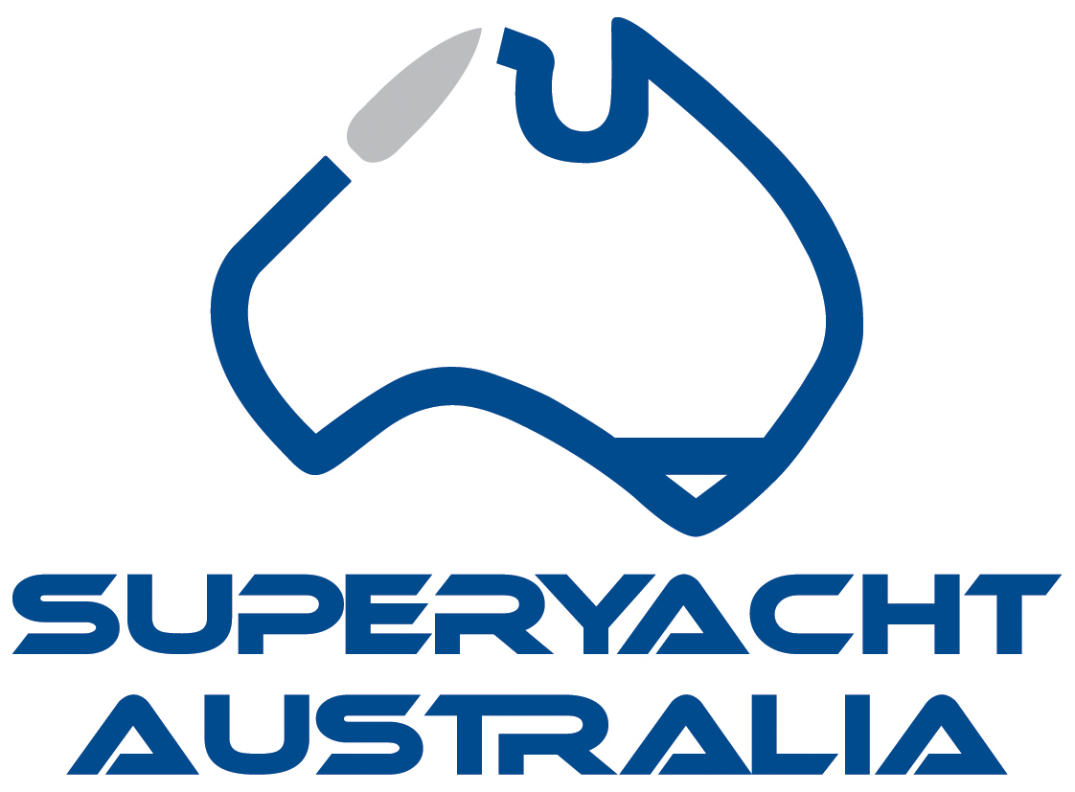

IMPORTANT INFORMATION

The Australian Marine Industry Awards are presented annually to reward the outstanding achievements of Australian businesses in the marine export, superyacht and commercial sectors. The Awards are organised by the Australian International Marine Export Group (AIMEX), Superyacht Australia and the Australian Commercial Marine Group (ACMG).

SUPERYACHT AWARDS ELIGIBILITY:
Applications are invited from current financial members of Superyacht Australia with a registered ABN that are involved in the Australian Superyacht sector.

SUBMITTING YOUR APPLICATION:
All applications must be submitted by email to mspencer@aimex.asn.au by the closing date Friday 2nd April, 2021 by 5pm AEST. Applications or further entry material will not be accepted after this date.

Please note: All entries must be completed on this application form and submitted by email in this word document electronic format. AIMEX will not accept applications that are hard copy or not on the AIMEX application form.

AWARDS PRESENTATION:
The Awards presentation will take place in conjunction with ASMEX at Sanctuary Cove on Tuesday 18th May, 2021.

CONFIDENTIALITY:
Information provided on the applications will be used for judging only, and will be treated as commercial-in-confidence by the organisers of the Awards. No information contained therein will be published without the express permission of the applicant.

JUDGING CRITERIA:
The judges' decision is final and no correspondence will be entered into.
Judging will be based on information supplied and its capacity to meet the specified criteria.

SUPERYACHT AWARD CATEGORIES:

- 2021 SUPERYACHT INDUSTRY SERVICE PROVIDER OF THE YEAR
This award recognizes your services to the Superyacht Industry. To qualify for this category your business must be an Australian business either state based or national. Entries must be based on services undertaken between 1 Jan– 31 Dec 2020.

- 2021 SUPERYACHT INDUSTRY PROJECT/ DESIGN OR MANUFACTURER OF THE YEAR
This award recognises your product in the Superyacht Industry. To qualify for this category your business must be an Australian business either state based or national. Entries must be based on projects undertaken between 1 Jan– 31 Dec 2020.

INDUSTRY WIDE AWARD CATEGORIES:

- 2021 AUSTRALIAN MARINE INDUSTRY CHAMPION
This is an award which recognises an individual Australian’s efforts in the marine sector and how they have contributed to the success of the Australian marine industry.
This cannot be a self-nomination. The nomination must be put forward by an industry colleague/company who/which is an AIMEX, Superyacht Australia and/or ACMG member.

- 2021 AUSTRALIAN MARINE INDUSTRY APPRENTICE OF THE YEAR
This category was introduced last year and will recognise and reward an individual who is undertaking an apprenticeship within the Australian Marine Industry for outstanding commitment and dedication in all aspects of their training.
This can be a self-nomination OR a nomination put forward by the apprentices host company who/which is an AIMEX, Superyacht Australia and/or ACMG member.

- 2021 AUSTRALIAN MARINE INDUSTRY MARKETING STRATEGY OF THE YEAR
This is an award which recognises success from an innovative and effective marketing strategy implemented between Jan – Dec 2020.
Applicant must be AIMEX, Superyacht Australia and/or ACMG member.

COMPLETING THE APPLICATION:

- It is critical that applicants ensure they answer the questions posed for each category.
- Applicants may choose to enter one or several categories.
- You must supply 2-4 photographs which best display your organisation, products or service in high resolution jpeg format for use in pre and post competition publications.
- You must supply your company logo in high resolution PNG format.

Please scroll down to complete your application for the 2021 Australian Marine Industry Awards.

Cover page

Place Logo Here

Picture

Picture

AUSTRALIAN MARINE INDUSTRY SUPERYACHT AWARDS 2020
APPLICATION FORM

CERTIFICATION
Name of your Organisation:

Year Established:
Year commenced Exporting if applicable:
Number of Employees:
Trading Name:
Address:
Suburb:
Postcode:
ABN:
Contact Name:
Job Title:
Telephone:
Mobile:
Email:
Website:
I certify that the following information is correct to the best of my knowledge.

Name:
Date:
Organisation name:
(This will be the wording you wish to be used in all publicity and on the award trophy)
Name and title of the person who would accept the award on behalf of the business:

SUPERYACHT AWARD CATEGORIES:

CATEGORY 1
2021 SUPERYACHT INDUSTRY SERVICE PROVIDER OF THE YEAR
(Total Submission Limit: 500 words)
This award recognises your services to the Superyacht Industry. Entries must be based on services undertaken between 1 Jan– 31 Dec 2020.

- Describe your Superyacht industry service, why you believe it to be valuable to the industry and how you provide excellent service to the industry in today’s environment. Consider the following:
- What is your business structure, when was it established?
- Explain how your service provides support to the Superyacht sector and what your key highlights that show your success in 2020.
- Was there a gap in the market for this service, what is your competitive advantage?

CATEGORY 2
2021 SUPERYACHT INDUSTRY PROJECT/ DESIGN OR MANUFACTURER OF THE YEAR
(Total Submission Limit: 500 words)
This award recognises your product in the Superyacht Industry. Entries must be based on projects undertaken between 1 Jan– 31 Dec 2020.

- Describe your Superyacht industry product and how it has been the outstanding project/design or build within the Superyacht industry in Australia and globally (if applicable). Consider the following:
- What is your business structure, when was it established?
- Explain how your project or/design or vessel is outstanding against all others in the Superyacht sector.
- Provide an overview of your strategy to leverage this excellence and drive business within the Superyacht sector.

INDUSTRY WIDE AWARD CATEGORIES:

CATEGORY 1
2021 AUSTRALIAN MARINE INDUSTRY CHAMPION
This is an award which recognises an individual Australian’s efforts in the marine sector and how they have contributed to the success of the Australian marine industry.
This cannot be a self-nomination. The nomination must be put forward by an industry colleague/company who/which is an AIMEX, Superyacht Australia and/or ACMG member.

PLEASE CLICK HERE TO ACCESS AND DOWNLOAD THE INDUSTRY CHAMPION OF THE YEAR APPLICATION FORM

CATEGORY 2
2021 AUSTRALIAN MARINE INDUSTRY APPRENTICE OF THE YEAR
This category was introduced last year and will recognise and reward an individual who is undertaking an apprenticeship within the Australian Marine Industry for outstanding commitment and dedication in all aspects of their training.
This can be a self-nomination OR a nomination put forward by the apprentices host company who/which is an AIMEX, Superyacht Australia and/or ACMG member.

PLEASE CLICK HERE TO ACCESS AND DOWNLOAD THE APPRENTICE OF THE YEAR APPLICATION FORM

CATEGORY 3
2021 AUSTRALIAN MARINE INDUSTRY MARKETING STRATEGY
This is an award which recognises success from an innovative and effective marketing strategy implemented between Jan – Dec 2020.
Applicant must be AIMEX, Superyacht Australia and/or ACMG member.

PLEASE CLICK HERE TO ACCESS AND DOWNLOAD THE MARKETING STRATEGY OF THE YEAR APPLICATION FORM

SUBMITTING YOUR APPLICATION:
Once complete, your application must be submitted by email to mspencer@aimex.asn.au by the closing date Friday 2nd April, 2021 by 5pm AEST.

Applications or further entry material will not be accepted after this date.

