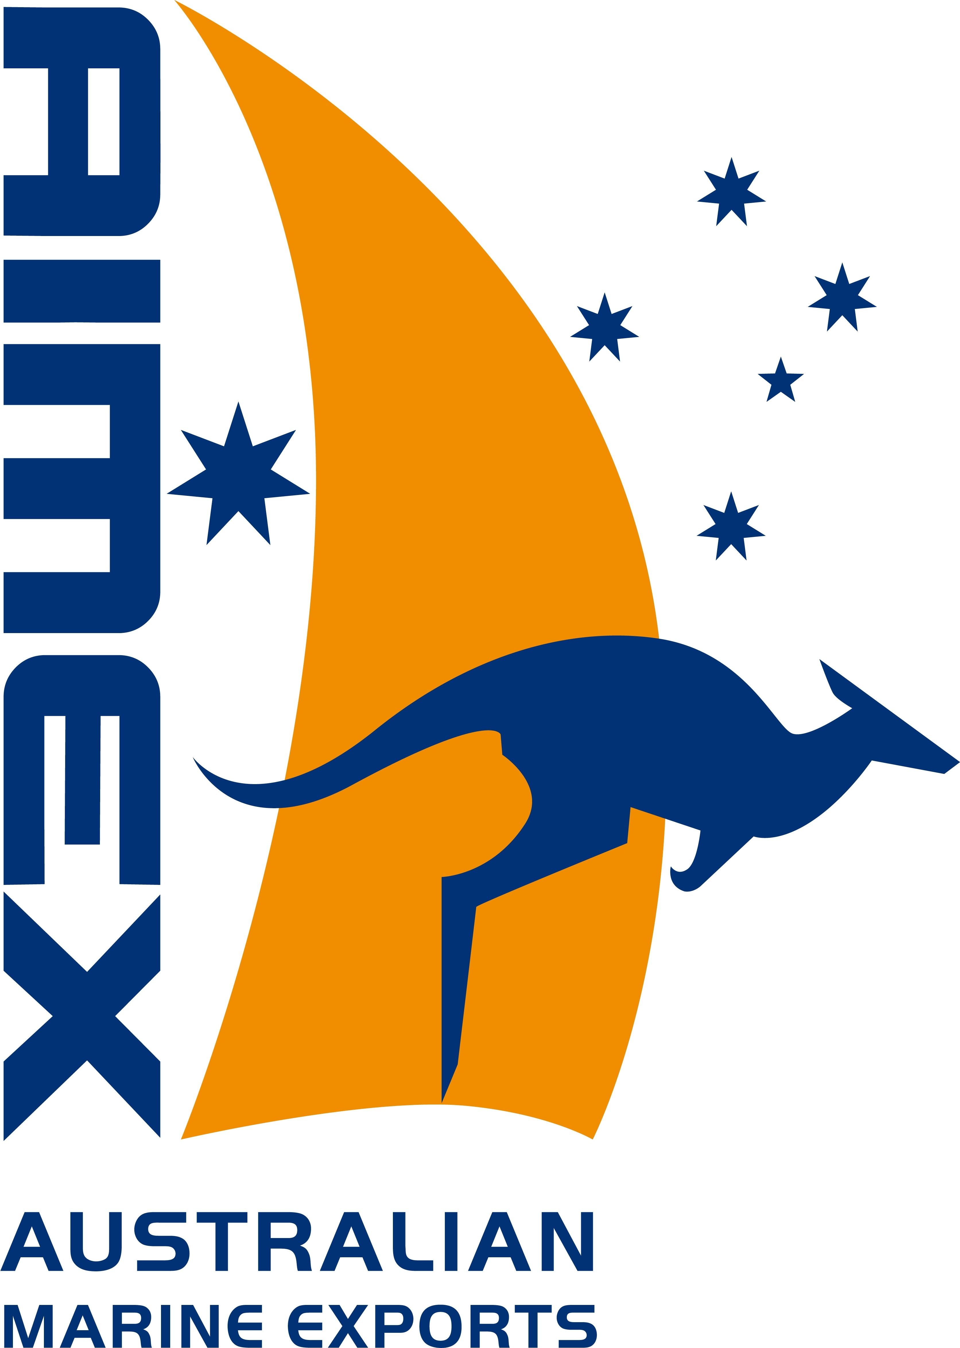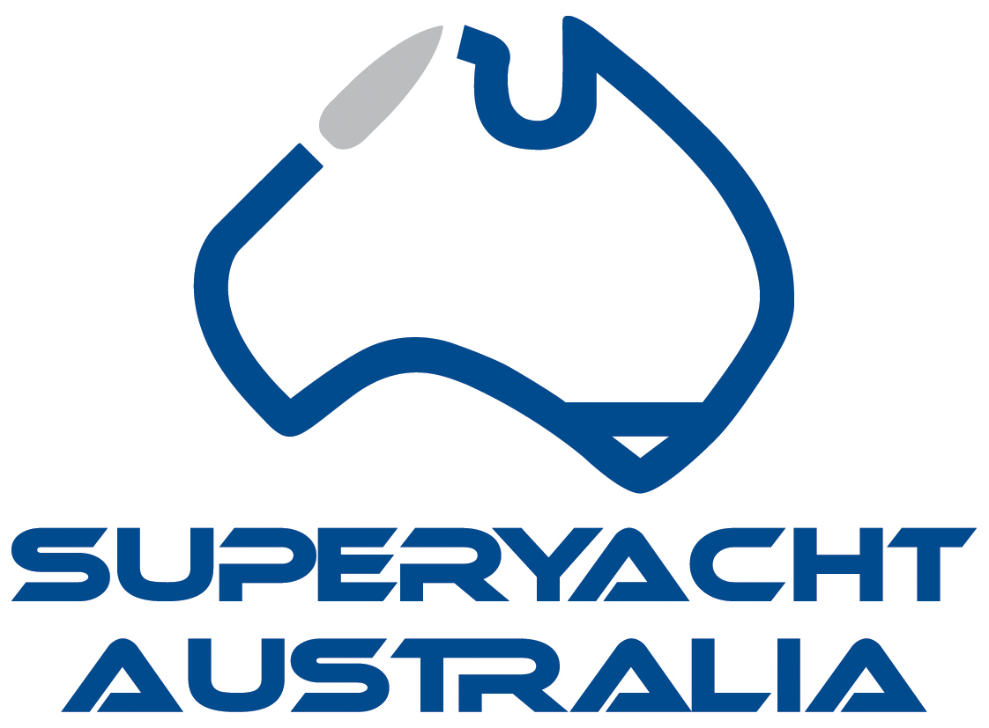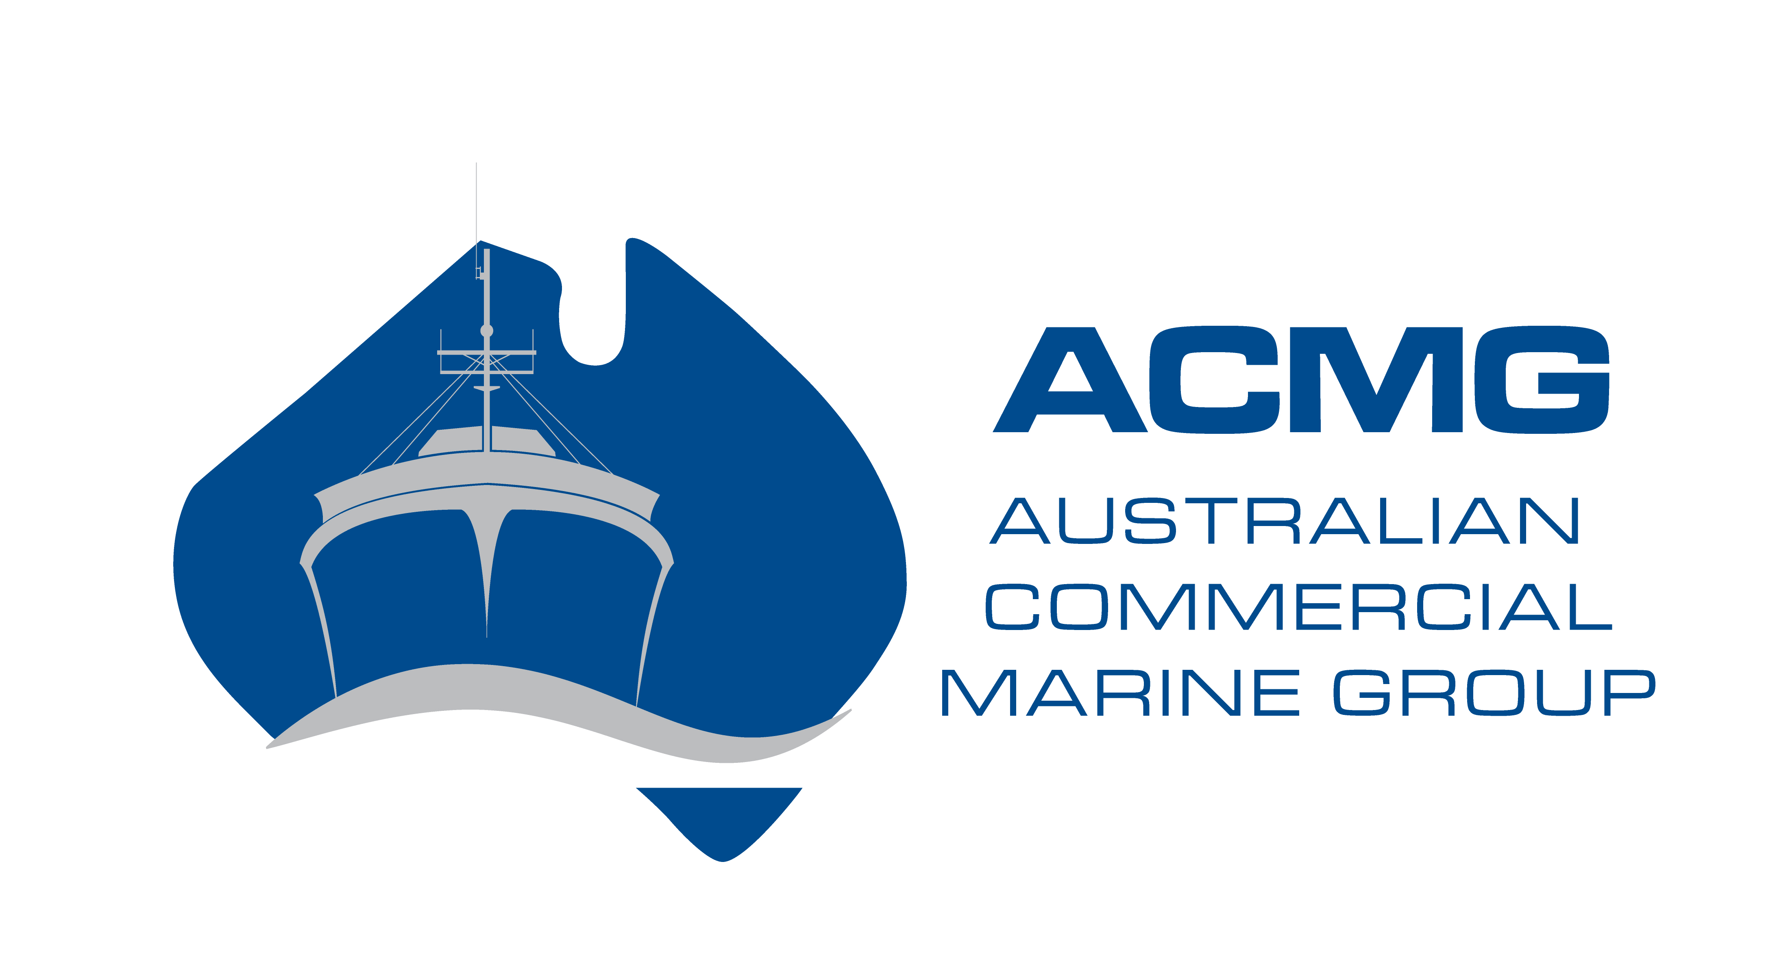

2021 AUSTRALIAN MARINE INDUSTRY CHAMPION

This is an award which recognises an individual Australian’s efforts in the marine sector and how they have contributed to the success of the Australian marine sector.
This cannot be a self-nomination. The nomination must be put forward by an industry colleague/company who/which is an AIMEX, Superyacht Australia and/or ACMG member.

IMPORTANT INFORMATION:
The Australian Marine Industry Awards are presented annually to reward the outstanding achievements of Australian businesses in the marine export, superyacht and commercial sectors. The Awards are organised by the Australian International Marine Export Group (AIMEX), Superyacht Australia and the Australian Commercial Marine Group (ACMG).

AWARDS ELIGIBILITY:
Applications are invited from current financial members of AIMEX, Superyacht Australia and/or ACMG with a registered ABN and a product or service in the marine industry sector that has significant contribution to the Australian marine industry.

SUBMITTING YOUR APPLICATION:
All applications must be submitted by email to mspencer@aimex.asn.au by the closing date Friday 2nd April, 2021 by 5pm AEST. Applications or further entry material will not be accepted after this date.

Please note: All entries must be completed on this application form and submitted by email in this word document electronic format. AIMEX will not accept applications that are hard copy or not on the AIMEX application form.

AWARDS PRESENTATION:
The Awards presentation will take place in conjunction with ASMEX at Sanctuary Cove on Tuesday 18th May, 2021.

CONFIDENTIALITY:
Information provided on the applications will be used for judging only, and will be treated as commercial-in-confidence by the organisers of the Awards. No information contained therein will be published without the express permission of the applicant.

JUDGING CRITERIA:
The judges' decision is final and no correspondence will be entered into.
Judging will be based on information supplied and its capacity to meet the specified criteria.

COMPLETING THE APPLICATION:

- You must supply 2-4 photographs (including 1 portrait image of the nominee) which best display their organisation, products or service in high resolution jpeg format for use in pre and post competition publications.
- You must supply your company logo in high resolution PNG format.

Please scroll down to complete your application for the 2021 Australian Marine Industry Awards.

Cover page

Place Logo Here

Picture

Picture

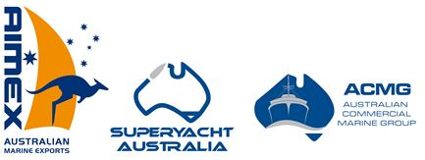
AUSTRALIAN MARINE INDUSTRY CHAMPION
APPLICATION FORM

CERTIFICATION
Company Name:

Year Established:
Year commenced Exporting if applicable:
Number of Employees:
Trading Name:
Address:
Suburb:
Postcode:
ABN:
Nominee’s Name:
(This will be the wording you wish to be used in all publicity and on the award trophy)
Job Title:
Telephone:
Mobile:
Email:
Website:
I certify that the following information is correct to the best of my knowledge.

Name:
Date:
Organisation name:
Name and title of the person who would accept the award on behalf of the business:

NOMINEE OVERVIEW
(Total Submission Limit: 500 words)

- Please detail the nominee’s current profile/career overview including positions held within the industry
- Describe to the best of your knowledge the nominees’ personal contribution to Australia’s marine sector
- What are their most outstanding achievements in the marine sector?
- How have they promoted the Australian Marine sector internationally?

SUBMITTING YOUR APPLICATION:
Once complete, your application must be submitted by email to mspencer@aimex.asn.au by the closing date Friday 2nd April, 2021 by 5pm AEST.

Applications or further entry material will not be accepted after this date.

