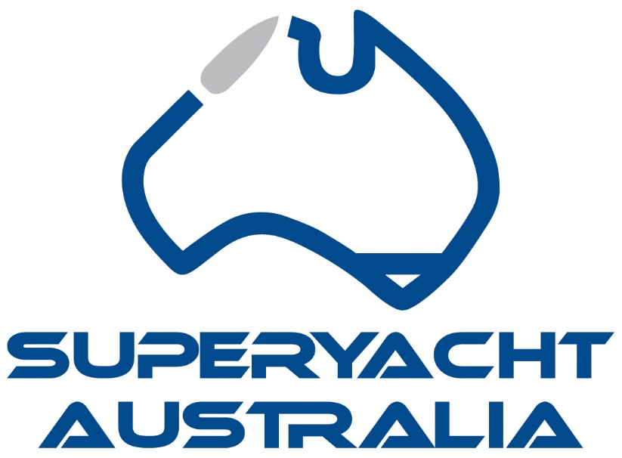
_____________________________________________________________________________

Australian Voyage Award

The Australian Voyage Award is a new category to the awards programme. Thanks, must go to Captain Carl Brandes and his wife Melanie Brandes who have sponsored this award. After their amazing experience of winning the prestigious Voyagers Award at the world Superyacht Awards they wanted to offer others the opportunity to feel the pride in winning such an award.
Australia has some of the most spectacular cruising experiences found anywhere in the world. Superyachts are spoilt for choice with locations to please even the fussiest of guests. Take a pick from our world-renowned locations, from Sydney Harbour, the Great Barrier Reef, Tasmania, the Kimberley Region, to the islands of the Coral Sea, and everything in between. The spectacular Superyacht destinations Australia has to offer are only limited by the imagination. The Australian climate allows full 12 months of cruising pleasure, so there is no doubt that the entrant’s itineraries will be rich and diverse, covering all seasons and regions.

Important Information

ELIGIBILITY:
Applications are invited for the most inspirational cruise during 2017 in Australian Waters or the majority in Australian Waters from any owner or a person nominated by the owner (for instance the principal of a charter party but NOT a member of the crew) who must have been aboard for a significant proportion of the cruise.
SUBMITTING YOUR APPLICATION:
All applications must be submitted by email to ljohnson@aimex.asn.au by the closing date Friday 23rd March, 2018 at 5pm AEST. Applications or further entry material will not be accepted after this date.
Please note: All entries must be completed on this application form and submitted by email in this word document electronic format. AIMEX will not accept applications that are hard copy or not on the AIMEX application form.
AWARDS PRESENTATION VENUE:
The Awards presentation will take place immediately prior to the 2018 Sanctuary Cove International Boat Show, on the evening of Tuesday 22nd May 2018.
CONFIDENTIALITY:
Information provided on the applications will be used for judging only, and will be treated as commercial-in-confidence by the organisers of the Awards. No information contained therein will be published without the express permission of the applicant.
JUDGES:
- Barry Jenkins
- Austrade Representative
- Tourism Australia Representative
- Captain Carl and Melanie Brandes
- Maryanne Edwards

JUDGING CRITERIA:
The judges' decision is final and no correspondence will be entered into. Judging will be based on information supplied and its capacity to meet the specified criteria.
COMPLETING THE APPLICATION:
- The Voyage of the year will be judged not only on the voyage but also the way it is described in text, photos and other media.

- A brief account of the cruise. Its length should not exceed three (3) A4 pages. We do understand that many world-roaming yachts are continuously on the move, but for the purposes of this award we ask you to select starting and finishing points that were on your track between the qualifying dates for this year’s event, 1 January 2017 and the 31 December 2017. The text should inform the judges of noteworthy events and landfalls along your route.

- Charts: A minimum of one (1) chart showing the track of your yacht. This should be marked up to show significant stopping places and should also indicate your progress by showing dates at suitable intervals along the track.

- Photographs and video footage:
a) Yachts may submit a MAX of 50 photographs taken during the voyage
b) Video footage of the voyage

Please scroll down to complete your application for the 2018 Australian Marine Industry
Awards.
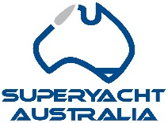AUSTRALIAN MARINE INDUSTRY SUPERYACHT AWARDS 2018
APPLICATION FORM

CERTIFICATION
Name of Vessel:

Captain:
Start Location:
Finish Location:
Address:
Suburb:
Postcode:
Telephone:
Mobile:
Email:
Website:

I certify that the following information is correct to the best of my knowledge.

Name :
Date:
Name of vessel:
(This will be the wording you wish to be used in all publicity and on the award trophy)

Name and title of the person who would accept the award on behalf of the business at the Awards presentation evening on 22nd May 2018

- A brief account of the cruise. Its length should not exceed three (3) A4 pages. We do understand that many world-roaming yachts are continuously on the move, but for the purposes of this award we ask you to select starting and finishing points that were on your track between the qualifying dates for this year’s event, 1 January 2017 and the 31 December 2017. The text should inform the judges of noteworthy events and landfalls along your route.

- Charts: A minimum of one (1) chart showing the track of your yacht. This should be marked up to show significant stopping places and should also indicate your progress by showing dates at suitable intervals along the track.

- Photographs and video footage:
a) Yachts may submit a MAX of 50 photographs taken during the voyage
b) Video footage of the voyage

