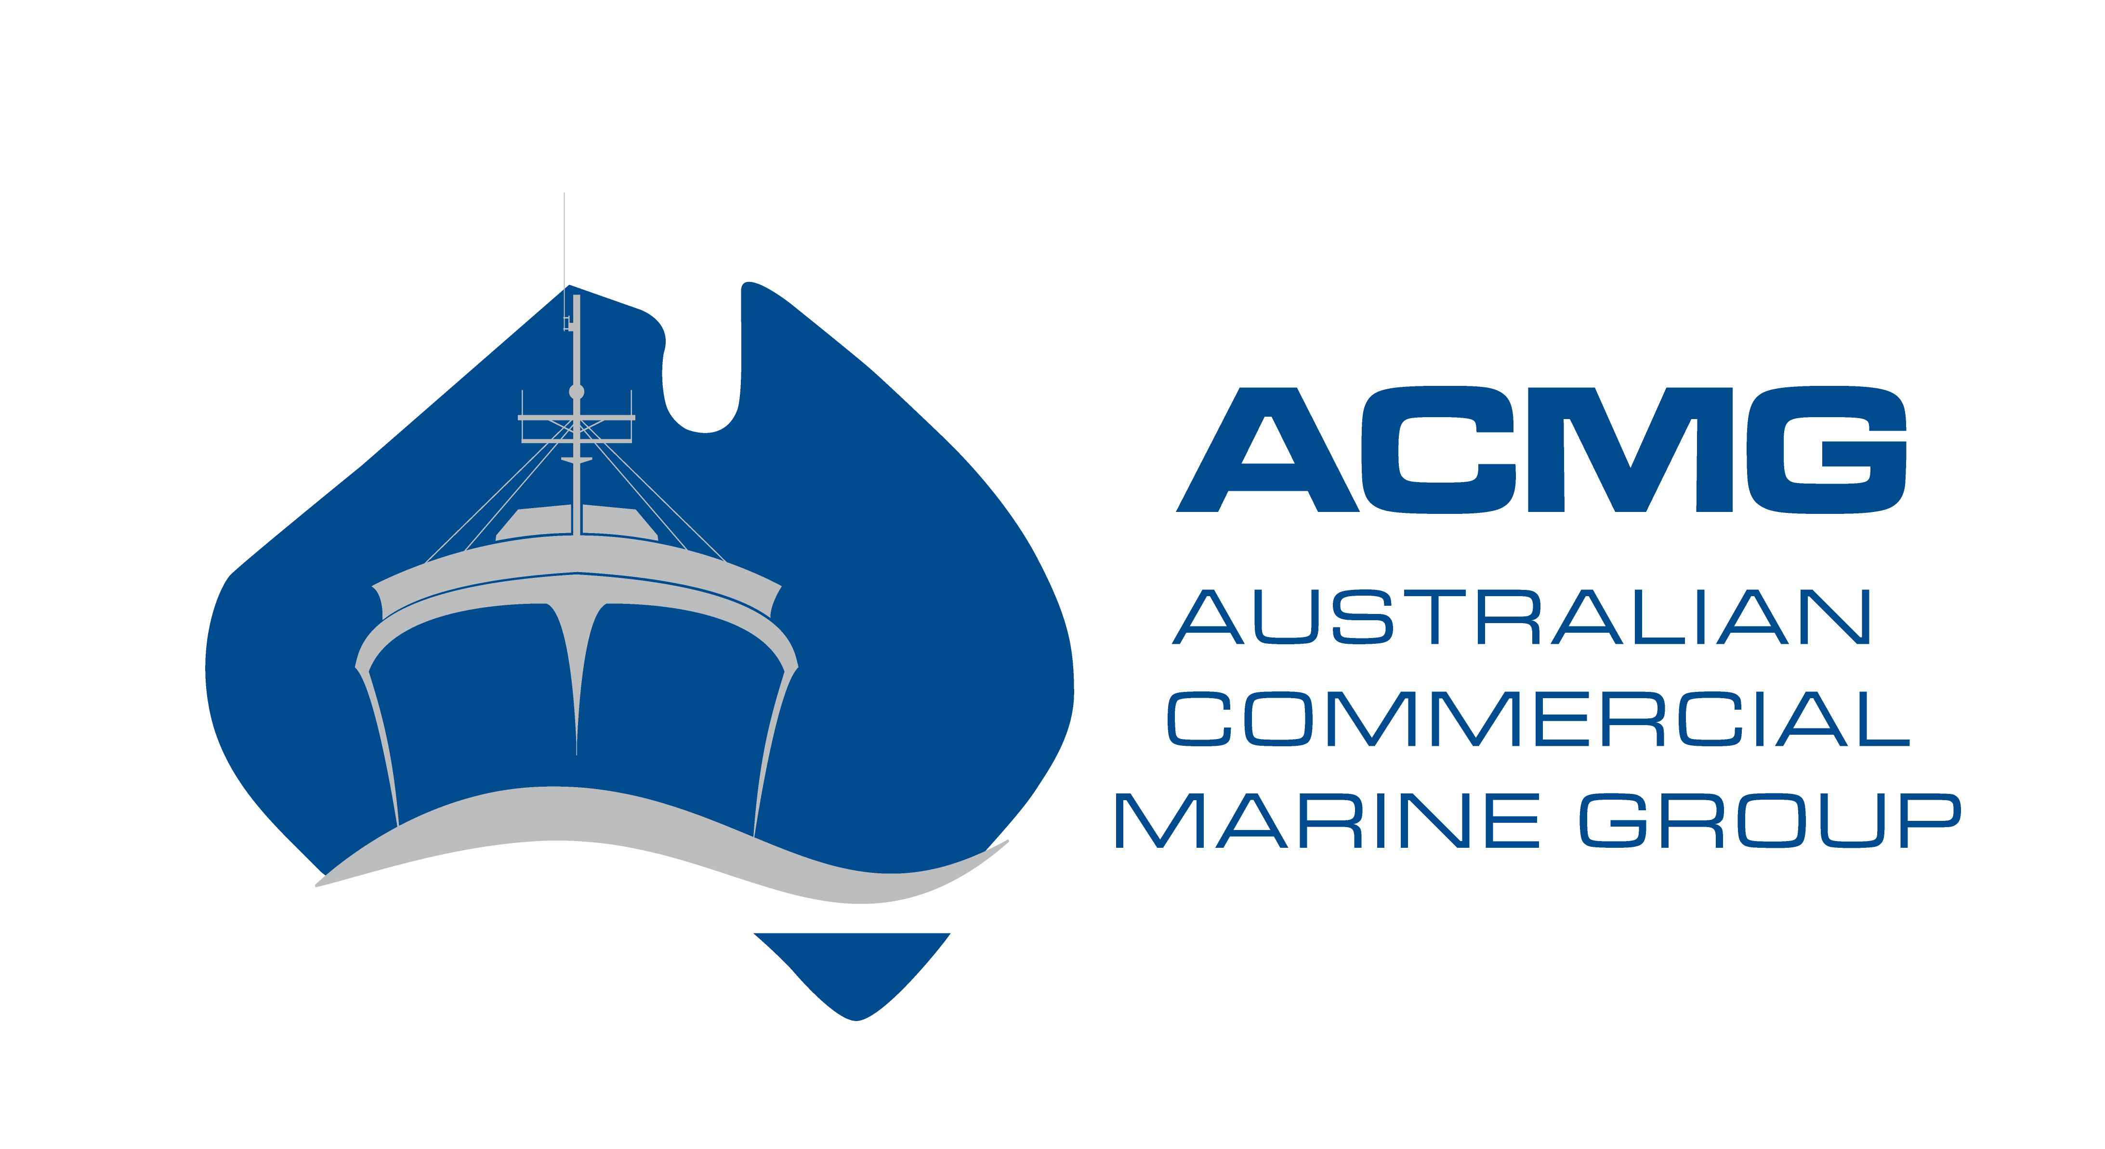

IMPORTANT INFORMATION

The Australian Marine Industry Awards are presented annually to reward the outstanding achievements of Australian businesses in the marine export, superyacht and commercial sectors. The Awards are organised by the Australian International Marine Export Group (AIMEX), Superyacht Australia and the Australian Commercial Marine Group (ACMG).

COMMERICAL AWARDS ELIGIBILITY:

Applications are invited from any organisation or firm that has a registered ABN and a product or service in the non-recreational marine industry sector that has significant contribution to the Australian commercial marine industry.

SUBMITTING YOUR APPLICATION:
All applications must be submitted to the Australian Commercial Marine Group (ACMG) by email to ljohnson@aimex.asn.au by the closing date Friday 23rd March, 2018 at 5pm AEST. Applications or further entry material will not be accepted after this date.

Please note: All entries must be completed on this application form and submitted by email in this word document electronic format. ACMG will not accept applications that are hard copy or not on the ACMG application form. On the cover page of your application form please place x1 logo and 2 accompanying photos.

AWARDS PRESENTATION:
The Awards presentation will take place immediately prior to the 2018 Sanctuary Cove International Boat Show, on the evening of Tuesday 22nd May 2018.

CONFIDENTIALITY:
Information provided on the applications will be used for judging only, and will be treated as commercial-in-confidence by the organisers of the Awards. No information contained therein will be published without the express permission of the applicant.

JUDGES:
The judging panel for the 2018 Australian Marine Industry Awards are:
- Barry Jenkins
- Ken Evans
- John Zammit
- Joe Akacich
- Anton Helmke
- Steve Mitchell

JUDGING CRITERIA:
The judges' decision is final and no correspondence will be entered into.
Judging will be based on information supplied and its capacity to meet the specified criteria.

AWARD CATEGORIES:

- 2018 COMMERCIAL MARINE MANUFACTURER OF THE YEAR
This award recognises product manufacture and shipbuilding in the Australian commercial marine sector (i.e. non-recreational marine).

- 2018 COMMERCIAL MARINE SERVICE PROVIDER OF THE YEAR
This award recognises service provision in the Australian commercial marine sector.

- 2018 MOST INNOVATIVE MARINE INDUSTRY COMMERCIAL PRODUCT OR SERVICE
This award recognises the innovation in products and services launched to the market in 2017 (i.e. sales have been made – product is past the proof of concept stage).

- COMMERCIAL MARINE INDUSTRY CHAMPION
This is an award which recognises an individual Australian’s efforts in the commercial marine sector and how they have contributed to the success of the Australian commercial marine sector. This cannot be a self-nomination. The nomination must be put forward by an industry colleague/company who/which is an AIMEX, Superyacht Australia and/or ACMG member. (Max 500 words)

COMPLETING THE APPLICATION:

- It is critical that applicants ensure they answer the questions posed for each category.

- Each question in the commercial categories is marked out of 25 points and a winner will be selected for each category.

- Applicants may choose to enter one or several categories.
- Answers to all categories are limited to 500 words each.

- You must supply 2-4 photographs which best display your organisation, products or service in high resolution jpeg format for use in pre and post competition publications.

- You must supply your company logo in high resolution jpeg format.

Please scroll down to complete your application for the 2018 Australian Marine Industry Awards.
Cover page

Place Logo Here

Picture

Picture

AUSTRALIAN COMMERCIAL MARINE AWARDS 2018
APPLICATION FORM

CERTIFICATION
Name of your Organisation:

Year Established:
Year commenced Exporting if applicable:
Trading Name:
Address:
Suburb:
Postcode:
ABN:
Contact Name:
Job Title:
Telephone:
Mobile:
Email:
Website:

I certify that the following information is correct to the best of my knowledge.

Name :
Date:
Organisation Name:
(This will be the wording you wish to be used in all publicity and on the award trophy)

Name and title of the person who would accept the award on behalf of the business at the Awards presentation evening on 22nd May 2018

DESCRIPTION OF PRODUCT OR SERVICE

Describe your product or services

DESCRIPTION OF APPLICANT'S BUSINESS

Please provide an executive summary detailing the ownership structure of the business, employee numbers, years in operation etc:

CATEGORY 1
2018 COMMERCIAL MARINE MANUFACTURER OF THE YEAR (max 500 words)
This award recognises product manufacture and shipbuilding in the Australian commercial marine sector (i.e. non-recreational marine).

- Describe your commercial marine product/s
- What is your business structure, when was it established, how many employees did you have in the last 3 years
- What are your business growth rates over the last 3 years
- What are your key strategies for success
- Provide an overview of your marketing strategy to drive business within the commercial sector
- Was there a gap in the market for this product
- What is your competitive advantage
- What percentage of your turnover is exported
CATEGORY 2
2018 COMMERCIAL MARINE SERVICE PROVIDER OF THE YEAR (max 500 words)
This award recognises service provision in the Australian commercial marine sector.

- Describe your commercial marine service, why you believe it to be valuable to the industry and how you provide excellent service to the industry in the global marketplace
- What is your business structure, when was it established, how many employees did you have in last 3 years
- What are your business growth rates over the last 3 years
- Explain how your service provides support to the commercial marine sector
- What are your key strategies for success
- Provide an overview of your marketing strategy to drive business within the commercial sector
- Was there a gap in the market for this service
- What is your competitive advantage
- What percentage of your turnover is exported
CATEGORY 3
2018 MOST INNOVATIVE MARINE INDUSTRY COMMERCIAL PRODUCT OR SERVICE (max 500 words)
This award recognises the innovation in products and services launched to the market in 2017 (i.e. sales have been made – product is past the proof of concept stage).

Criteria:
- Describe your commercial marine industry product/service, why you believe it to be innovative
- How will it provide excellent potential within the commercial marine industry in today’s global environment
- Explain how your product or service is at the forefront of innovation including how the demand for the product was identified and explain the process undertaken to develop the product
- How has it been introduced to the market and how has it been accepted
- Was there a gap in the market that you filled with this innovation
- How has the culture within your business supported this innovation

CATEGORY 4
COMMERCIAL MARINE INDUSTRY CHAMPION (max 500 words)
This is an award which recognises an individual Australian’s efforts in the commercial marine sector and how they have contributed to the success of the Australian commercial marine sector. This cannot be a self-nomination. The nomination must be put forward by an industry colleague/company who/which is an AIMEX, Superyacht Australia and/or ACMG member.
Criteria:
- Please detail the nominee’s current profile/career overview including positions held within the industry
- Describe to the best of your knowledge the nominees’ personal contribution to Australia’s commercial marine sector
- What are their most outstanding achievements in the commercial marine sector
- What other industry awards have they achieved
- What are their professional aspirations and strategies
- How have they promoted the Australian Commercial Marine sector internationally

